***Roboozle challenge***

1. Complete all tutorials on this site: <http://www.robozzle.com/beta/index.html?puzzle=-1>
2. Solve all puzzles below

1. The easy one

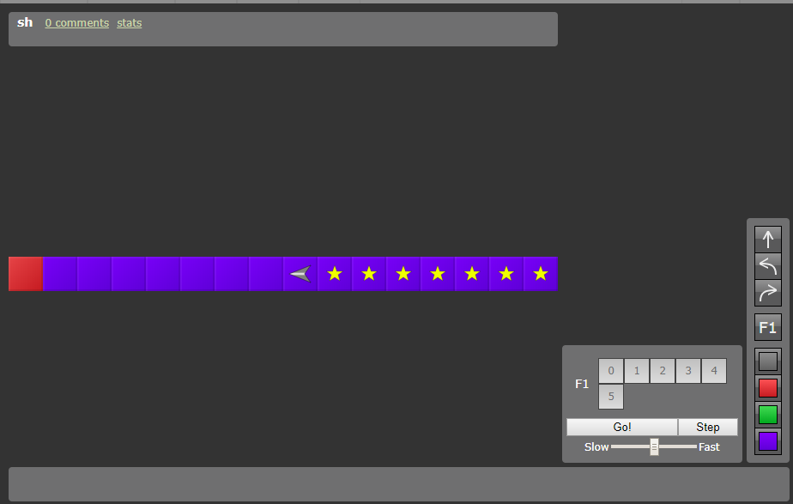

<http://www.robozzle.com/beta/index.html?puzzle=140>

2. Still easy

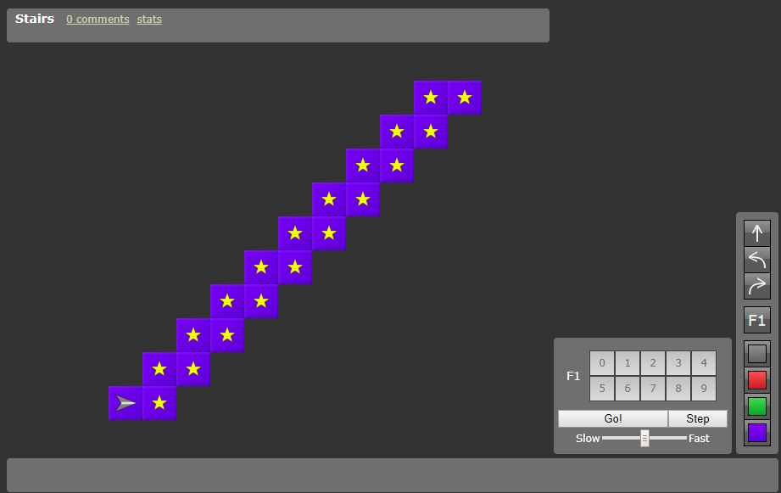

<http://www.robozzle.com/beta/index.html?puzzle=27>

3. A little bit harder

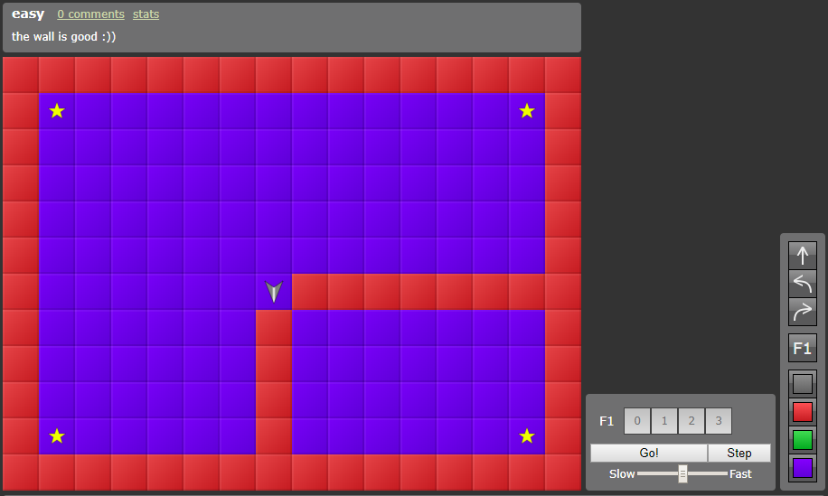

<http://www.robozzle.com/beta/index.html?puzzle=643>

4. The hard one

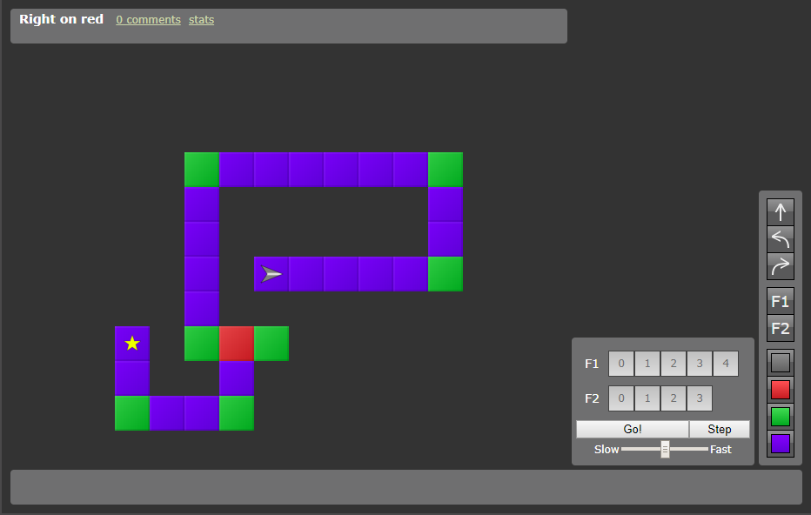

<http://www.robozzle.com/beta/index.html?puzzle=644>

5. Don’t panic

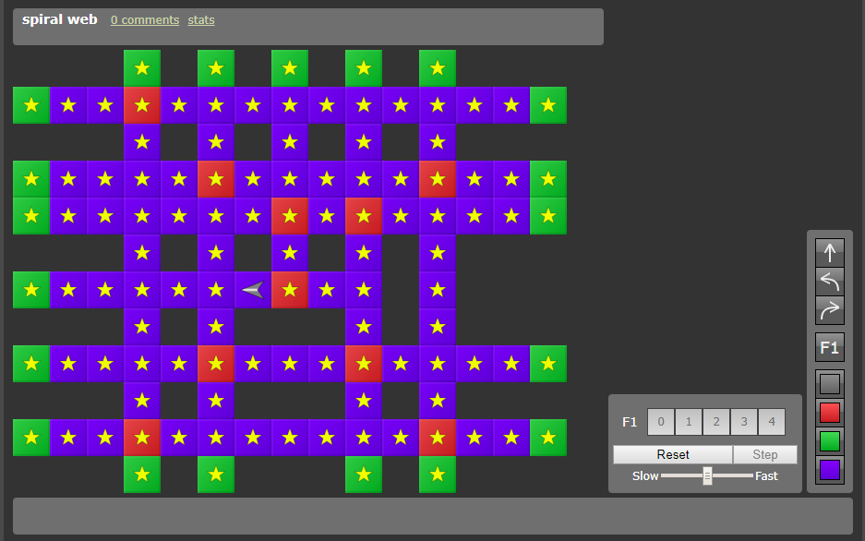

<http://www.robozzle.com/beta/index.html?puzzle=483>

6. The final boss

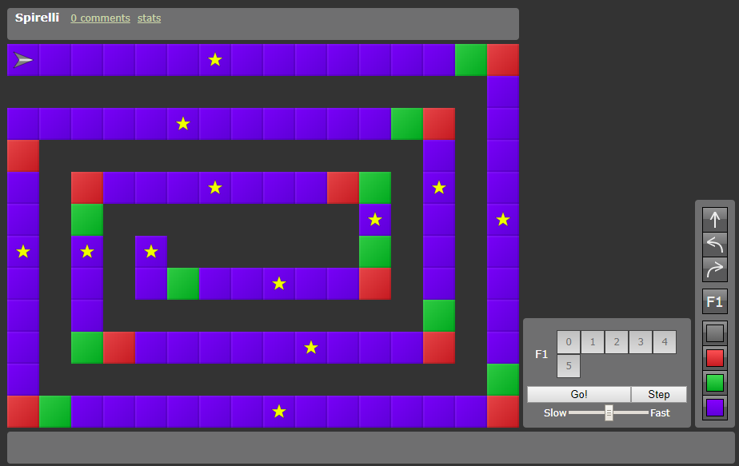

<http://www.robozzle.com/beta/index.html?puzzle=532>